QICSS Summer School on Research Reproducibility

TITLE : Summer School in Research Reproducibility: Ensuring the Transparency and Credibility of Your Work
- May 26, 9 AM to 4 PM and May 27, 2025, 9 AM to 12 PM
- In person at UQAM, Montreal (location TBD)
- In English

This intensive training explores the fundamental principles of reproducibility, a pillar of open science that ensures the transparency and credibility of scientific research. You will discover best practices to make your work reproducible, from data management to code documentation, version control, and results publication.

OBJECTIVES
- Master the challenges and principles of research reproducibility
- Acquire technical skills to create reproducible projects
- Learn to effectively document your analyses and code
- Develop concrete strategies for data management and sharing

WHO SHOULD ATTEND
This training is intended for researchers of all levels (graduate students, faculty, research staff) with experience in empirical data analysis. Knowledge of at least one statistical software package (Stata, R, Python, SPSS, SAS) is required.
Participants must bring their own laptop with their preferred statistical software.

Sponsored by: the QICSS and the Research Group on Human Capital of UQAM’s School of Management (ESG UQAM).

INSTRUCTORS

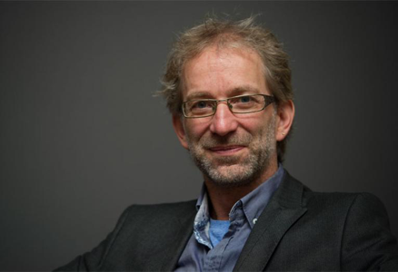 | Lars Vilhuber holds a Ph.D. in Economics from Université de Montréal, and is currently on the faculty of the Cornell University Economics Department. He has interests in labor economics, statistical disclosure limitation and data dissemination, and reproducibility and replicability in the social sciences. He is the current Data Editor of the American Economic Association.
 | Second instructor (TBD)

